Javascript Quirks Quiz #2

Please do not run the code in your terminal. Think critically about the answer.

\* Required

Name \*



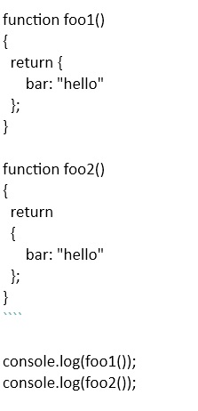

1) What will be the output of the above code snippet? \*

my ans (A) correct: C

Object {bar: "hello"} / Object {bar: "hello"}

undefined / Object {bar: "hello"}

Object {bar: "hello"} / undefined

undefined / undefined

first return Object{bar:foo}

return defined

semicolons are tech optional in JS

As result when the line containing the return statement (with nothing

https://lh3.googleusercontent.com/2hqgtzOB2g_U_WXuc3G5rbZtKudXRWgK23vriilGzny0E2_g4da_ucbTn2YuKFQdlYCoJnVdhw=w162

2) What will be the output of the above code snippet? \*

NaN compared to itself is false;

isNaN() ----NOT reliable

Number.isNaN() ---- as of ES6- reliable

Value !== value ----- RELIABLE

(1) Correct: 4Number

"undefined"

"object"

undefined

"number"

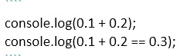

3) What will be the output of the above code snippet? \*

(1)

Correct Ans: 4 . FALSE

a # is floating point number with a limited precision of 64bits about 16digits

because of limited precision of floating point numbers round-off errors can occur during calculations

999999999999999999999 === 100000000000000000 is true also

0.3 / true

0.30000000000000004 / true

0.3 / false

0.30000000000000004 / false

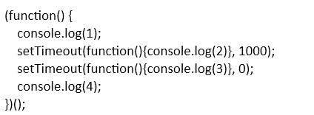

4) What will be the output of the above code snippet? \* (2)

choice 4 correct;

1, 2, 3, 4

1, 3, 4, 2

1, 4, 2, 3

1, 4, 3, 2

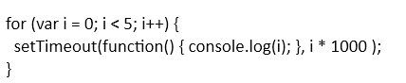

5) What will be the output of the above code snippet? \* (1)

correct answer: 5555

0, 1, 2, 3, 4

0, 0, 0, 0, 0

4, 4, 4, 4, 4

5, 5, 5, 5, 5

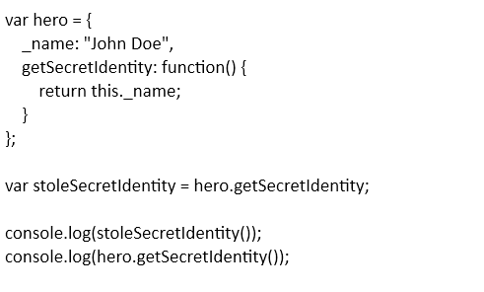

6) What will be the output of the above code snippet? \* (3)

Correct answer undefined/John Doe

"John Doe" / "John Doe"

undefined / undefined

"John Doe" / undefined

undefined / "John Doe"

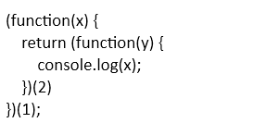

7) What will be the output of the above code snippet? \* (1) Correct(1)

1

2

undefined

Error

https://lh6.googleusercontent.com/JRHBP2mwWXc5skqYOyJNqNw0mrsDURFsu-FatM0MEXV3TEX7uMqHNdj_klVvgaSW5xh0RDP90w=w519

8) What will be the output of the above code snippet? \* (1) correct(2)

undefined

3628800

Error

0

https://lh3.googleusercontent.com/ikqZjJUe_5otPscPiDgf0gUPVmQ2F806aN1b-FTwxL3MuBPSDgeHyW2xLdCo_0lhvljkhakWPg=w250

9) What will be the output of the above code snippet? \* (3) correct (3)

true / true

true / false

true / false

false / false

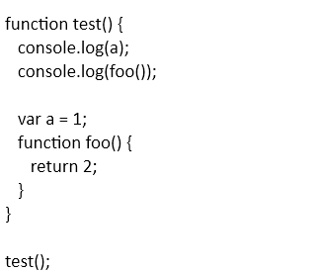

10) What will be the output of the above code snippet? \* (4) correct 4

undefined / undefined

1 / 2

1 / undefined

undefined / 2

SUBMIT